**Create an IAM Role**

* **Creating an IAM role**
* In the IAM panel, click on Roles -> Create role

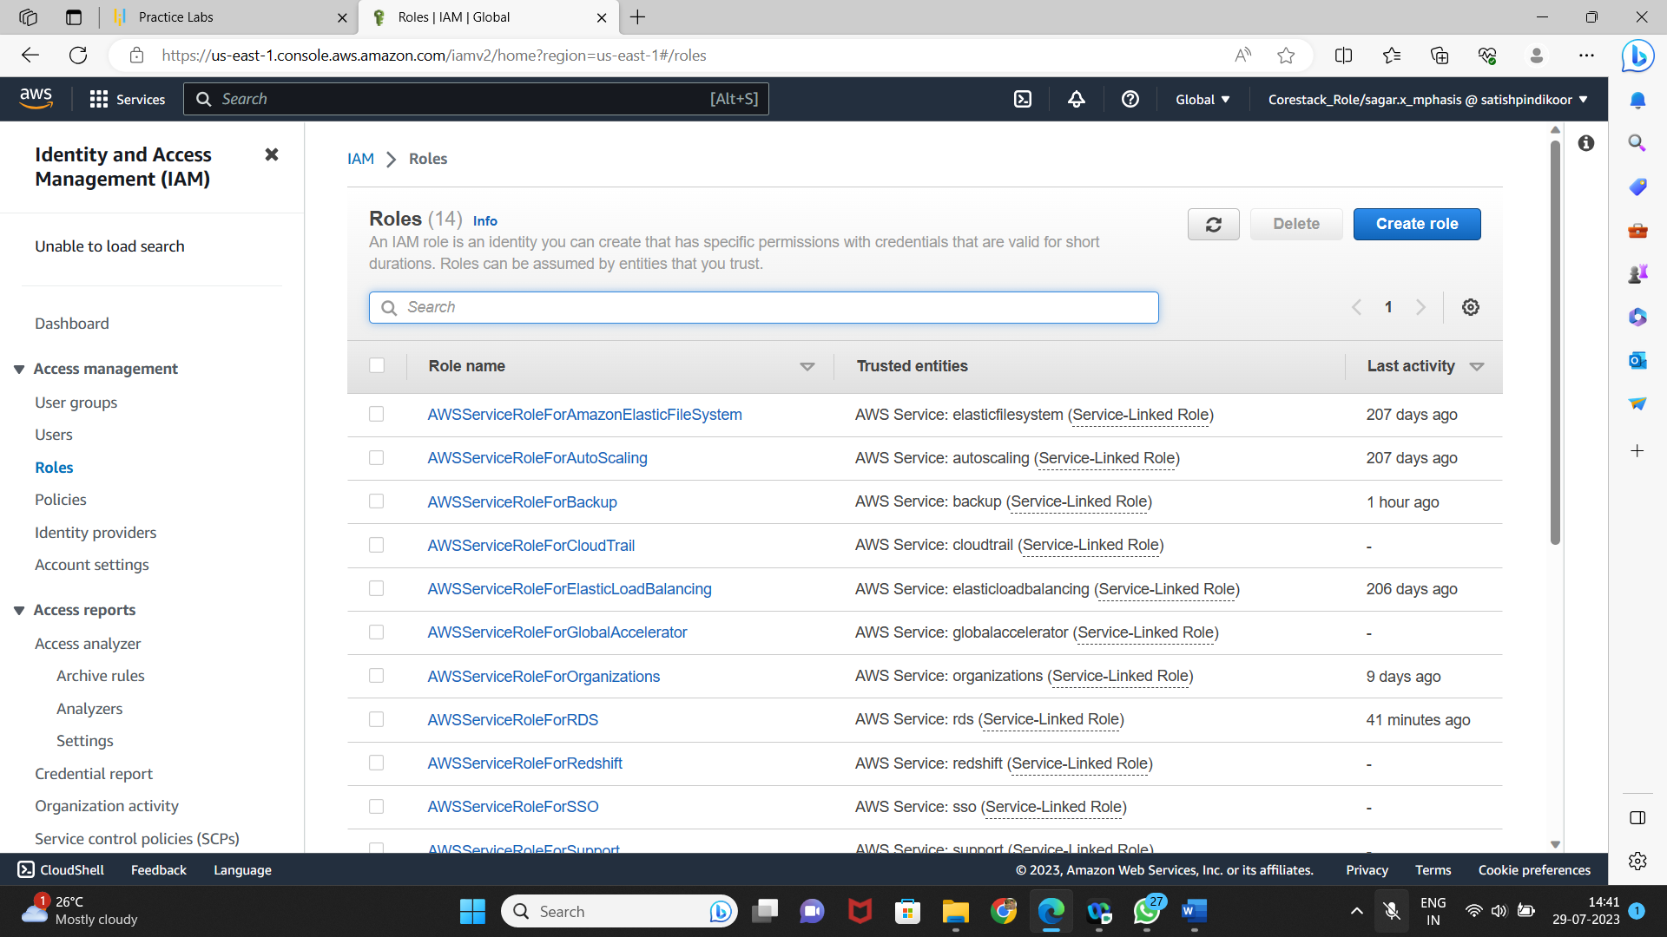

* Select the service

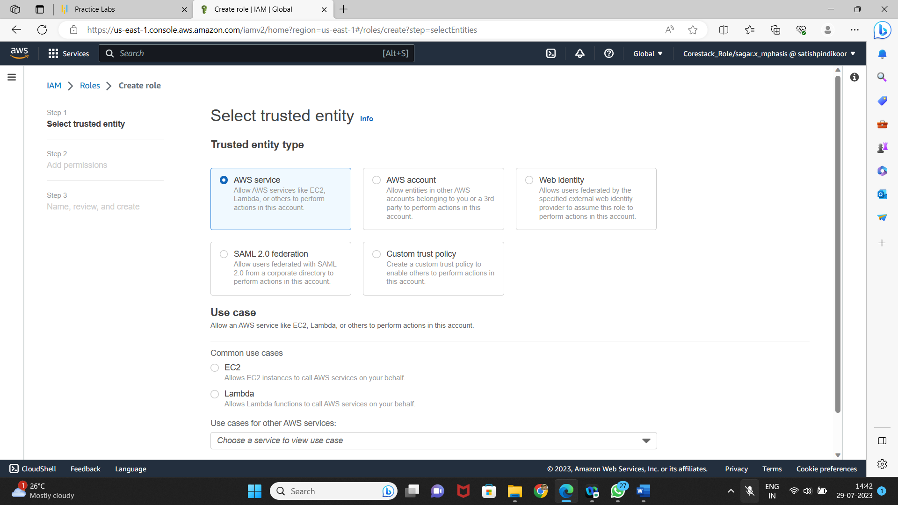

* **Adding AWS policy to the role**

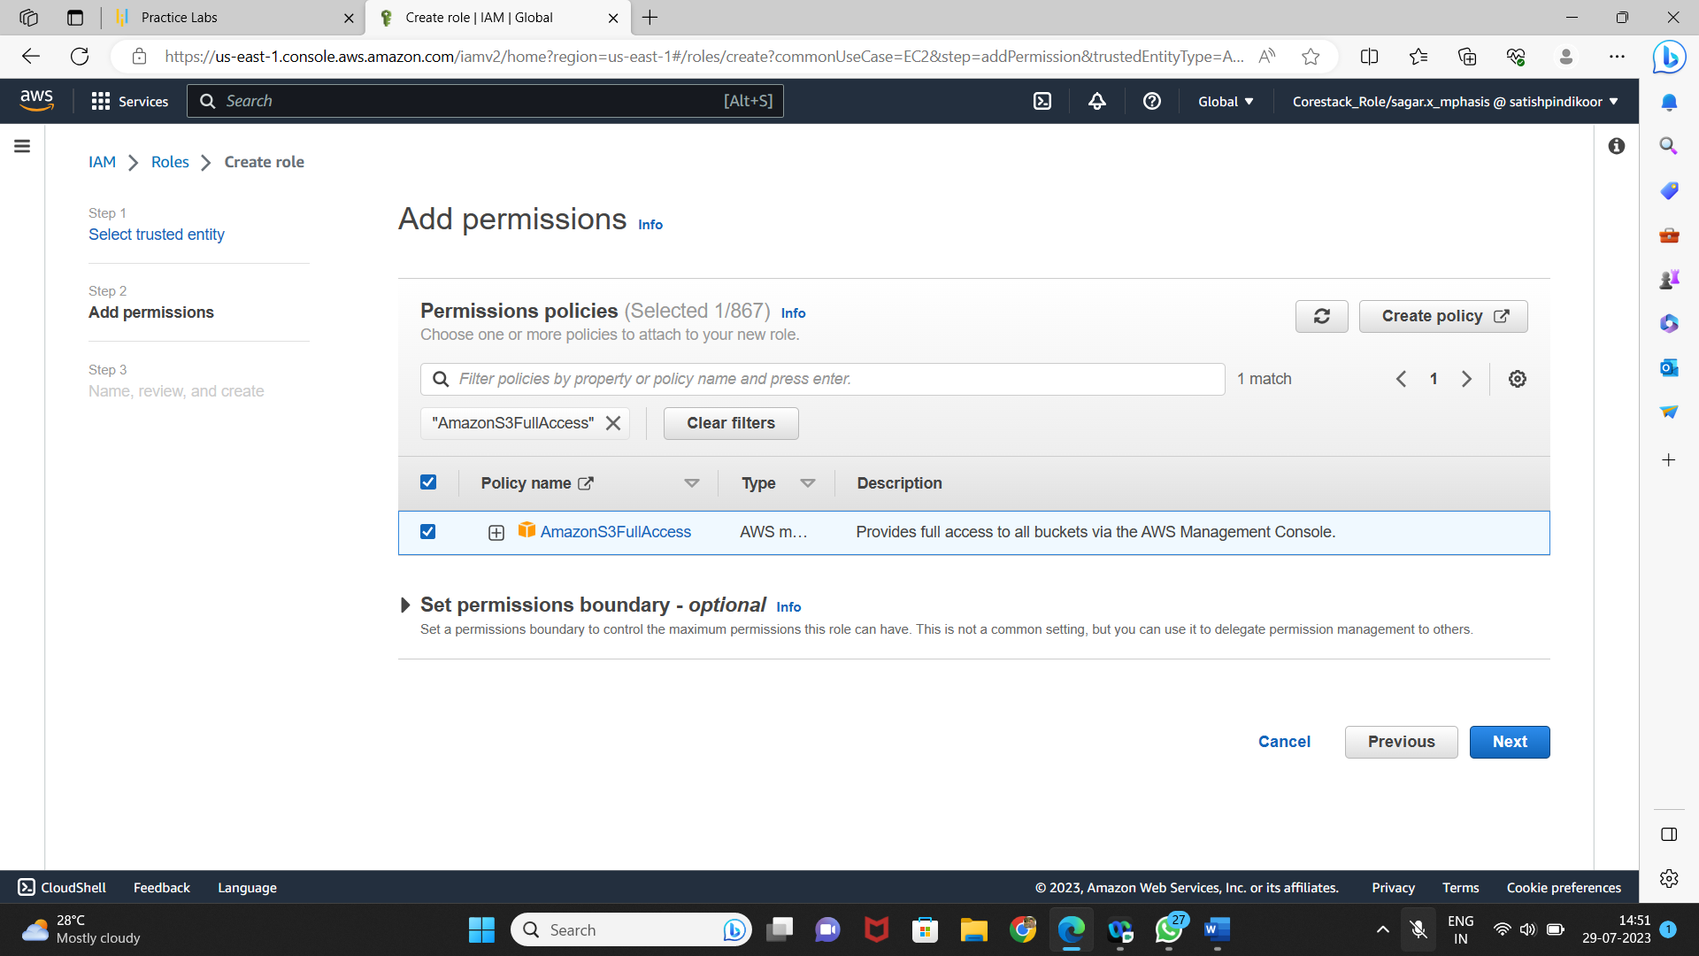

* **Providing a key and a value for the role**
* Add a role name, key and a value to the role

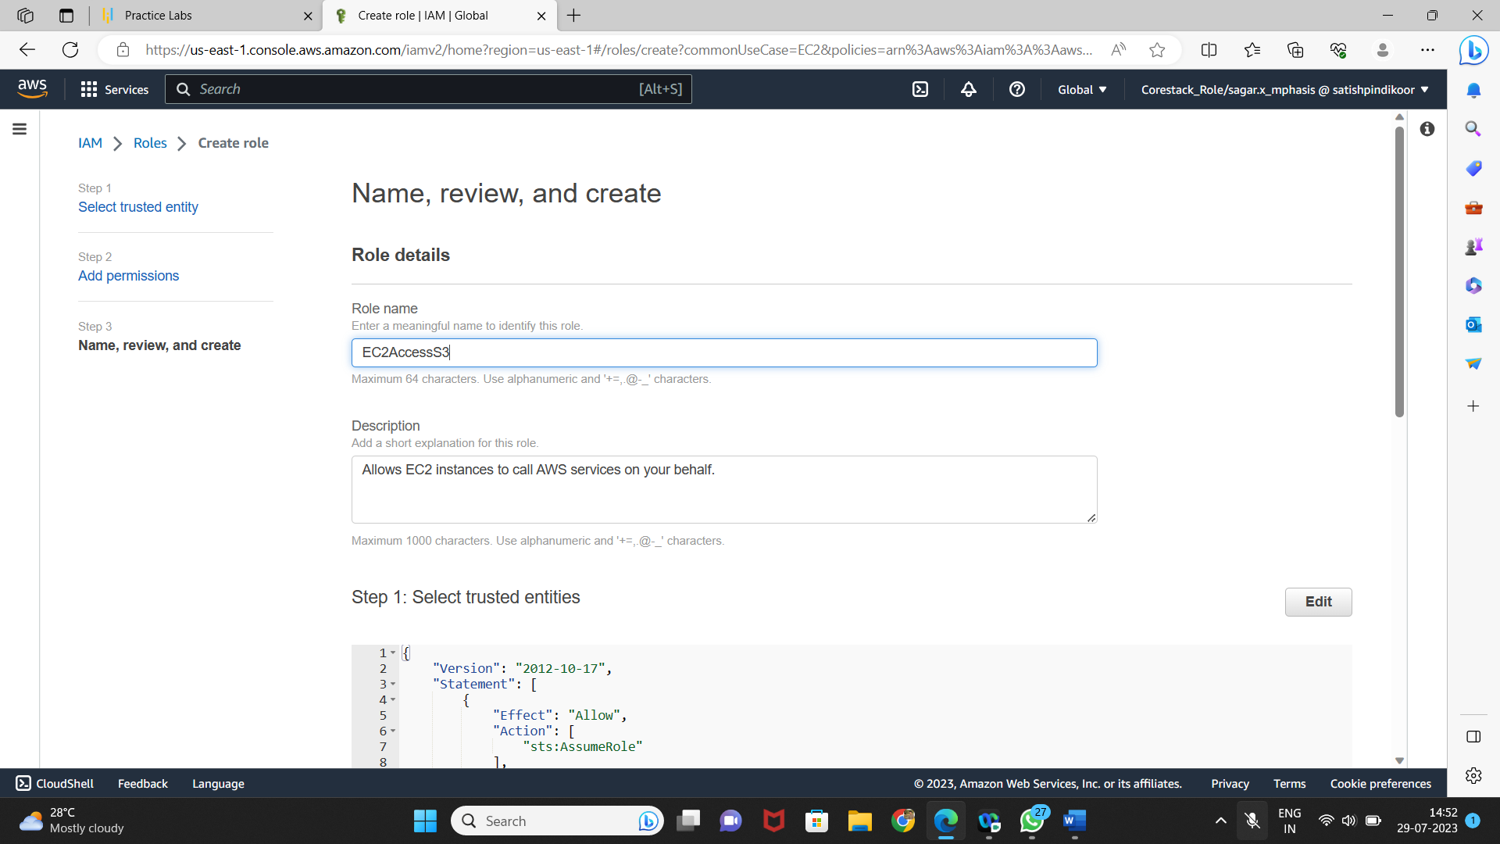

* Once the role is created, you can find it in the IAM panel

